**PEACE RIVER PRESBYTERY**

5600 Peace River Road

North Port, Florida 34287

**Commuter Volunteer Team**

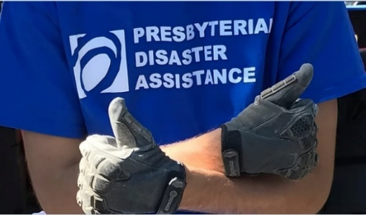Presbyterian Disaster Assistance (PDA) has a long and robust history of supporting volunteers engaged in long-term recovery. Most recently, PDA has collaborated with response volunteer teams, some coming from neighboring states, to address basic needs immediately after a disaster.

On March 11, 2020 the World Health Organization characterized the COVID-19 outbreak as a pandemic. Overnight, COVID-19 changed the world fundamentally and universally, including how disaster preparedness, response, and recovery are carried out. That is why PDA and Florida Presbyterian Disaster Assistance Network (FLAPDAN) are testing a model for disaster volunteers for COVID-19 that may also be adapted for future pandemics.

Stay at home orders, social distancing protocols, personal protective equipment (PPE), prohibitions to inter-state travel, and other mandates require disaster response and recovery organizations to adapt. Until a vaccine is discovered and administered, it is no longer possible to send deployed personnel into a disaster area because they will need overnight lodging and meals.

One adaptation organizations are implementing is using “commuter volunteers”. These volunteers would travel by car/van and bring all they need for a day’s work (food, water, PPE, tools) without the need for lodging.

PDA and FLAPDAN are working with Presbyteries to develop a Commuter Volunteer model in states with a history of high disaster incidences. Because Florida is such a state, and because PDA and FLAPDAN have a long history of partnership, the model is proposed to be developed and tested with the six Presbyteries in Florida, FLAPDAN and PDA.

After a disaster, a team of Presbytery commuter volunteers will provide their own transportation to the work site and return home the same day. Overnight lodging will not be provided. The typical work includes muck/gut, debris removal, and temporary repairs to stop additional home damage. If you are interested in more information or would like to register as a presbytery volunteer,

please contact:

**Contact Information:**

**Clint Belk**

[hcbelk@bellsouth.net](mailto:hcbelk@bellsouth.net)

(864) 316-9468

[Register Here](https://bit.ly/2ExPaPN)